**Learning Translation Using Gobak Sodor Game**

**Harisman Nizar1, Zulkardi2*, Ratu Ilma Indra Putri3, Budi Mulyono4, Ely Susanti5**

**1Mathematics Education, Universitas Islam Negeri Raden Fatah Palembang**

**Jalan Prof. KH. Zainal Abidin Fikri, Palembang, Sumatera Selatan, Indonesia**

[**1*harismannizar_uin@radenfatah.ac.id***](mailto:1harismannizar_uin@radenfatah.ac.id)

**1,2*,3,4,5Mathematics Education, Universitas Sriwijaya**

**Jalan Palembang-Prabumulih, Indralaya, Sumatera Selatan, Indonesia**

[**2\**zulkardi@unsri.ac.id***](mailto:2*zulkardi@unsri.ac.id)***;*** [**3*ratuilma@unsri.ac.id***](mailto:3ratuilma@unsri.ac.id)***;*** [**4*budi_mulyono@fkip.unsri.ac.id***](mailto:4budi_mulyono@fkip.unsri.ac.id)***;*** [**5*ely_susanti@fkip.unsri.ac.id***](mailto:5ely_susanti@fkip.unsri.ac.id)

**Article received: 15-11-2024, revision: 13-12-2024, published: 30-01-2025**

**Abstrak**

Translasi merupakan salah satu konsep dasar dalam transformasi geometri yang mengajarkan tentang pergerakan benda tanpa mengubah bentuk, ukuran, atau arah benda tersebut. Pemahaman yang baik tentang translasi dapat mengembangkan keterampilan visualisasi dan spasial siswa, yang relevan dengan berbagai disiplin ilmu seperti teknik, fisika, dan arsitektur. Penelitian ini mengintegrasikan pembelajaran translasi dengan konteks permainan gobak sodor. Penelitian ini menghasilkan lintasan pembelajaran yang berkontribusi bagi siswa untuk memahami konsep translasi. Metode design research yang digunakan, yang terdiri dari tahapan-tahapan, yaitu persiapan eksperimen, pelaksanaan eksperimen, dan analisis retrospektif. Teknik pengumpulan data yaitu dokumentasi, observasi, dan wawancara. Teknik analisis data yaitu secara kualitatif. Penelitian dilaksanakan di kelas IX, pada tahap pilot experiment dengan 8 siswa dan pada tahapan teaching experiment terdiri dari 14 siswa. Hasil penelitian menunjukkan bahwa rangkaian aktivitas berkontribusi untuk siswa memahami konsep translasi.

Kata Kunci: desain pembelajaran; gobak sodor; HLT; translasi

**Abstract**

Translation is a fundamental concept in geometric transformation, teaching the movement of objects without changing their shape, size, or direction. A good understanding of translation can develop students' visualization and spatial skills, which are relevant to various disciplines such as engineering, physics, and architecture. This study integrates translation learning with the context of the game of gobak sodor. This research produces a learning trajectory that contributes to students' understanding of the concept of translation. The design research method used consisted of the following stages: experimental preparation, experimental implementation, and retrospective analysis. Data collection techniques included documentation, observation, and interviews. Data analysis techniques used were qualitative. The study was conducted in grade IX, with eight students participating in the pilot experiment and 14 students participating in the teaching experiment. The results showed that the series of activities contributed to students' understanding of the concept of translation.

Keywords: learning design; gobak sodor; HLT; translation

1. **Introduction**

Mathematics is a fundamental field of study in education that plays an important role in honing critical, logical and analytical thinking skills in students (Saragih, 2019; Adrianingsih et al., 2024). The various mathematical concepts that students learn are not only theoretical, but also applicable, including in the field of geometric transformations that include translation, rotation, reflection, and dilation. Translation is one of the basic concepts in geometric transformations that teaches about moving objects without changing the shape, size, or direction of the object. A good understanding of translation can develop students' visualization and spatial skills, which are relevant to various disciplines such as engineering, physics, and architecture.

Despite its importance, understanding the concept of translation is often an obstacle for many students. Research (Maulani & Zanthy, 2020) shows that many students frequently struggle to grasp geometry transformation concepts, including translation. Conventional teaching methods that generally only focus on lectures and practice questions are seen as less helpful in aiding students’ comprehension of the concept of translation in depth. In addition, conventional approaches are also less able to increase student interest and involvement in learning (Sariningsih, 2014; Siregar, Siagian, & Syahlan, 2024). To overcome these obstacles, a more engaging and contextual innovative approach is needed.

Game-based learning is known as one of the effective learning methods in increasing student motivation and participation (Aysila, 2023; Nugroho et al., 2021; Putri et al., 2017; Tan et al., 2007). Utilizing traditional games as a medium for learning mathematics can make learning mathematics more meaningful (Zulviansyach et al., 2023). Games create an interactive and fun learning atmosphere, and facilitate students in understanding complex concepts through direct experience. Traditional games, with their strong cultural roots, offer great potential as a fun and effective learning medium, particularly in instilling an understanding of geometric concepts such as translation (Suhermi, 2025; Susanti et al., 2020; Tampubolon et al., 2023). The integration of traditional games in mathematics learning is not only an effort to make learning more interesting, but also a strategy to preserve local culture and instill national character values in the younger generation (Cahyadi et al., 2020; Irwansyah & Fransori, 2021). Translation, as one of the basic geometric transformations, is often considered complicated by students because of its abstract nature (Rosikhoh & Abdussakir, 2020) and lack of connection to the real world (Febrian & Perdana, 2018; Soto, 2021; Yanik & Flores, 2009). One of the traditional Indonesian games that has great potential as a context in learning mathematics is Gobak Sodor (Fanani & Sari, 2024; Nizar & Rahmawati, 2024). Gobak sodor, a classic game from tradition involving strategy, teamwork, and physical movement, can be used as a tool to visualize and internalize the concept of translation intuitively (Pratalaharja & Dirgantoro, 2021; Suhermi, 2025). This game involves coordination skills, teamwork, and strategy related to movement or translation in mathematics. One of the traditional games enjoyed in South Sumatra is Gobak Sodor. Some say that Gobak Sodor comes from Yogyakarta and consists of the words Gobak and Sodor (Annastasia F.Q., 2021). Gobak means to move freely and sodor means spear (Annastasia F.Q., 2021; Sumarsono, 2022). In the past, soldiers had a game called sodoran as a skill training in war. Sodor is a spear with a length of approximately 2 meters, without a sharp spearhead at the end.

In the game Gobak Sodor, players move within a certain area and perform various movements to avoid or catch opponents. Through the rules of this game, students can learn the concept of translation, which is the movement of objects in the coordinate plane. By playing Gobak Sodor, students not only learn translation in theory, but also gain direct experience in applying the concept through physical movement. This supports the constructivist theory which states that students are better able to grasp and remember the concepts through direct experience and interaction with the subject matter (Arafah et al., 2023; Hamid & Afriansyah, 2024).

This study aims to produce a translation learning trajectory using the context of the Gobak Sodor game to help students understand the concept of translation. It is hoped that the results of this study can contribute to the development of more innovative and relevant mathematics learning methods with local cultural contexts. With this context, It is hoped that students will be able to learn in a more engaging and enjoyable manner and gain a clearer understanding of the concepts presented in the material (Sembiring & Listiani, 2023). By integrating traditional games into mathematics education, this research aims to contribute positively to enhancing the quality of mathematics instruction in Indonesia. Furthermore, it is expected to serve as a resource for educators in designing innovative learning models that blend local cultural values with complex academic concepts, ultimately elevating the overall quality of mathematics learning.

1. **Method**

The subjects of the study were 14 ninth grade junior high school students in Palembang City in the 2024-2025 academic year. This study used a design research method of the Validation Studies type. The stages of the study refer to the stages of design research from (Gravemeijer & Cobb, 2006), including: 1) preparing for the experiment (preliminary design), 2) design experiment which includes (pilot experiment & teaching experiment), and 3) retrospective analysis. Data collection was carried out through student work, interviews, and observations. Descriptive techniques were applied in analyzing the data.

1. **Result and Discussion**
2. **Preparation for the Experiment**

At this stage, the researcher conducted an analysis based on a literature review related to mathematics learning on the topic of translation using the Indonesian Realistic Mathematics Approach. Researchers used the context of the game gobak sodor, chosen because it is familiar to students and is a traditional game. Furthermore, the context of the game gobak sodor can help students understand mathematics material (Nizar & Rahmawati, 2024). In this study, the learning trajectory focuses on understanding the concept of translation using the context of the game of gobak sodor. This understanding is gained by exploring the relationship between the positions of gobak sodor players, as defenders or attackers, from the starting point to the end point. After understanding this, students will discover the translation formula for points and apply it to everyday life. The results of this analysis produced a learning process design that aims to develop an understanding of the concept of translation. A Hypothetical Learning Trajectory (HLT) consists of student learning objectives, a planned learning activity, and predictions of the classroom learning process (Afriansyah & Arwadi, 2021). Based on the designed HLT, there is one learning activity that students will undertake in learning translation.

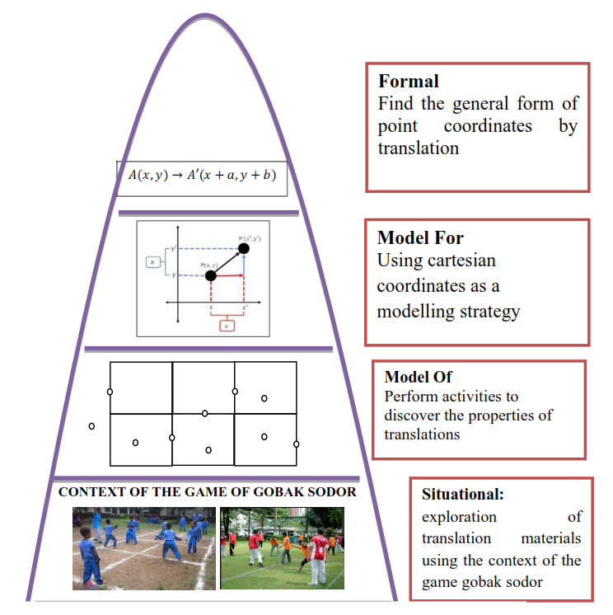

Figure 1. Iceberg.

In Figure 1, in the situational stage, students explore translation material using the game of gobak sodor, students explore by playing the game of gobak sodor as an attacking player and a guarding player. By directly playing the game of gobak sodor, it is hoped that it will be easier for students to explore translation material. In the model of stage, students carry out activities to discover the properties of translation, students answer questions in LAS. Students describe the position when being an attacking player from the initial position and the final position. Then students also describe the position when being a guarding player from the initial position and the final position. In the model for stage, students use Cartesian coordinates as a model strategy to solve problems. In the formal stage, students find the general form of point coordinates by translation.

The learning design was compiled using a Hypothetical Learning Trajectory (HLT), which is presented in Table 1.

Tabel 1.

Hypothetical Learning Trajectory

| Activity | Learning Objectives | Activity Description | Student Thinking Conjecture |
| --- | --- | --- | --- |
| Students play gobak sodor | Students can experience playing gobak sodor | The teacher directs students to play gobak sodor | Students play as gobak sodor players |
| Students write down the gobak sodor field and the formation of the gobak sodor game when playing. | Students can describe the gobak sodor field and the formation of the gobak sodor game when playing. | Students work in groups to describe the gobak sodor field and the formation of the gobak sodor game when playing. | Students try to describe the gobak sodor field and the formation of the gobak sodor game when playing. |
| Students write down points at positions when playing (starting position, moving position and end point of position when moving) in Cartesian coordinates. | Students can describe points at positions when playing (starting position, moving position and end point of position when moving) in Cartesian coordinates. | Students work in groups to describe points at positions when playing (starting position, moving position and end point of position when moving) in Cartesian coordinates. | Students try to describe points at positions when playing (starting position, moving position and end point of position when moving) in Cartesian coordinates. |
| Students write down the starting point, additions from the starting point, and ending points of the position when playing gobak sodor. | Students can write down the starting point, additions from the starting point, and ending point of the position when playing gobak sodor. | Students in groups write down the starting point, additions from the starting point, and ending points of the position when playing gobak sodor. | Students write down the starting point, additions from the starting point, and ending points of the position when playing gobak sodor. |
| Students conclude about translation | Students can write the concept of translation | Students in groups make conclusions about the concept of translation. | Students write the definition of translation |

The researcher analyzed the curriculum, namely analyzing the curriculum used in schools, namely the Merdeka curriculum, lesson plans, learning activities that contain the context of the game of gobak sodor, and media utilized in translation learning. The researcher conducted observations and consulted with mathematics teachers regarding translation learning activities and the research implementation schedule.

1. **Pilot Experiment**

In this stage, eight ninth grade students were selected to work on the PMRI learning activity sheet that focused on translation material using the context of the gobak sodor game. Before the students worked on the activity sheet, the researcher provided an explanation of the PMRI learning activities and how to fill in the activity sheet. It started with students playing gobak sodor. Students are divided into several groups, with one group playing offense and the other playing defense. The game begins by determining who will be the offense and who will be the defense. Students enjoy playing gobak sodor. After playing gobak sodor, students filled in the LAS.

The following passage is taken from an interview transcript involving students and researchers in the pilot experiment.

Researcher : Did it help you learn translation? After participating in the activities?

Student : It helped, sir.

Researcher : Have you ever played Gobak Sodor before?

Student : Yes, sir.

Researcher : What grade are you in?

Student : First and second grades of junior high school, and elementary school.

From the interview, it is clear that learning activities using the Gobak Sodor game context can help students better understand translation.

1. **Teaching Experiment**

In this stage, 14 ninth grade students were selected to work on the PMRI learning activity sheet that focused on translation material using the context of the gobak sodor game. Before the students worked on the activity sheet, the researcher provided an explanation of the PMRI learning activities and how to fill out the activity sheet. It started with students playing gobak sodor.

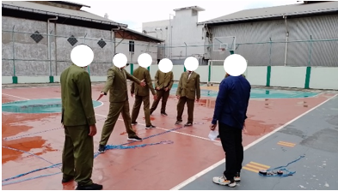

Figure 2. Students Playing Gobak Sodor.

In Figure 2, student play gobak sodor with each team consisting of 4 people. 1 team is tasked with being the guard player and the other team is the attacking team. The game begins with the team leader doing rock, paper, scissors to determine who is the attacking player.

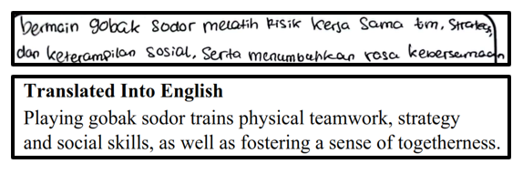

Figure 3. Student Answer.

In Figure 3, student answered what they got from playing gobak sodor. Students answered that playing gobak sodor trains physical teamwork, strategy and social skills, and fosters a sense of togetherness.

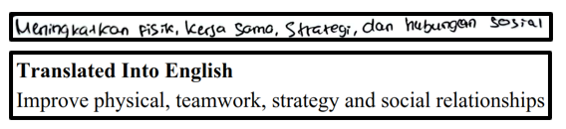

Figure 4. Student Answer.

In Figure 4, student answered about the benefits of playing gobak sodor. Students answered that it improves physical, cooperation, strategy, and social relationships.

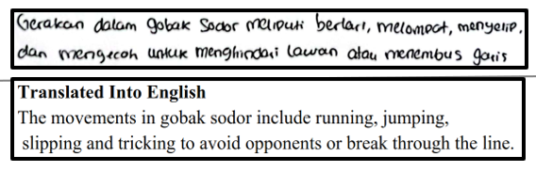

Figure 5. Student Answer.

In Figure 5, student' answer regarding what movements can be done in playing gobak sodor. Students answered that the movements in gobak sodor include running, jumping, slipping, blocking, and trying to avoid the opponent, or continuing to the next line.

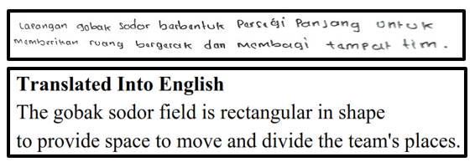

Figure 6. Student Answer.

In Figure 6 Student answered about the shape of the gobak sodor field. Students answered that the gobak sodor field is rectangular to provide space to move and divide the team's place.

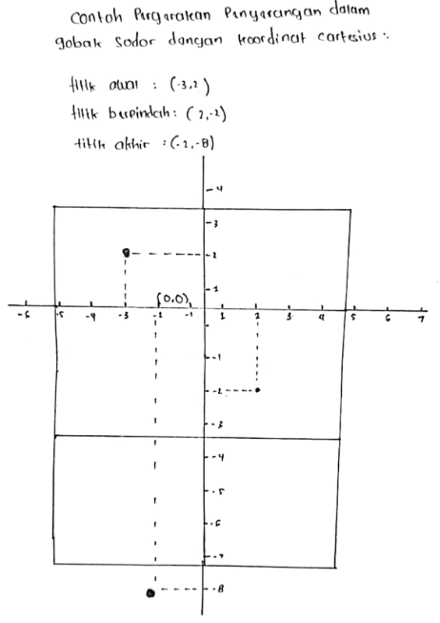

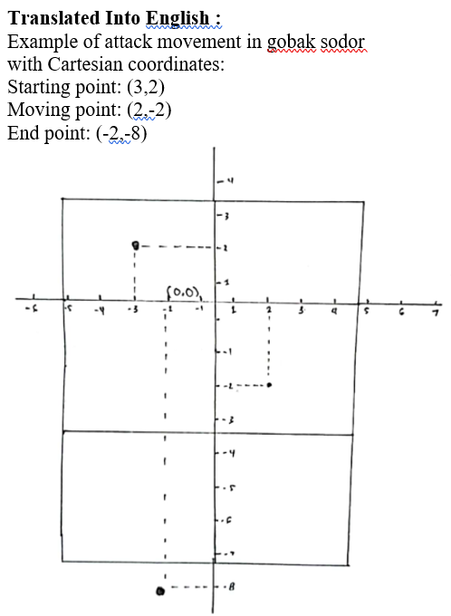

Figure 7. Student Answer.

In the Figure 7, the student writes the position of the attacking player in Cartesian coordinates with the initial position (-3,2), moving position (2,-2), and final position (-2,-8).

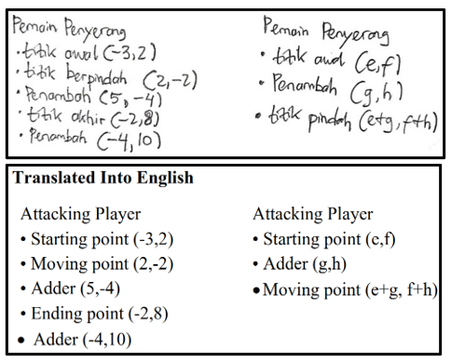

Figure 8. Student Answer.

In the Figure 8, the student writes the position as an attacker. Starting position (-3,2), changing position (-2,2), adder (5,-4), end point (-2,8), adder (-4,10). Then the students write down the example of the attacking player's point. Initial position (e,f), addition (g,h), moving point (e+g, f+h).

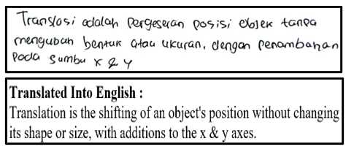

Figure 9 Student Make Conclusion.

In the Figure 9, students make conclusions about translation by writing that translation is a shift in the position of an object without changing its shape or size by adding to the x & y axes. From the students' answers, it may be concluded that applying the gobak sodor context aids students in understanding the concept of translation. The implementation of PMRI using the Gobak Sodor game as a context for teaching the concept of translation followed a structured approach. First, mathematics was integrated into daily life activities to address real-world problems encountered by students. By engaging in the Gobak Sodor game, students actively participated, enhancing their motivation and interest in learning mathematics while benefiting physically from the agility and speed required by the game. Second, models in realistic mathematics served as a bridge between real-life contexts and formal mathematical concepts through the mathematization process. Students documented their observations in worksheets, identifying the concept of translation by describing the starting point, transfer point, and endpoint during the Gobak Sodor game using Cartesian coordinates. Third, under teacher guidance, students were encouraged to explore mathematical concepts independently, fostering diverse problem-solving strategies and enabling them to identify the most effective methods for understanding the concept of translation. Fourth, interaction between students and teachers occurred through discussions, explanations, communication, collaboration, and evaluations. This student-centered learning process was evident in their work on learning activity sheets (LAS) and during presentations. Lastly, connections were established between mathematical topics and subjects, emphasizing the interconnected nature of mathematical concepts. Activities were designed to link the concept of translation with Cartesian coordinates and points, providing a cohesive learning experience.

This research also adhered to the three principles of PMRI: guided reinvention, didactical phenomenology, and self-developed models. Guided reinvention allowed students, with teacher support, to rediscover mathematical concepts through the Gobak Sodor game, aligning with progressive mathematization. Didactical phenomenology linked mathematical concepts with real-world phenomena, using the Gobak Sodor game to facilitate understanding of translation concepts. Self-developed models enabled students to transition from informal to formal stages by documenting attacker and defender positions on Cartesian coordinates, helping them to deepen their understanding of translation. The learning trajectory developed in this study began with playing the Gobak Sodor game, where students recorded their positions as attackers and guards using Cartesian coordinates. At the informal stage, these activities helped students grasp the concept of translation, and at the formal stage, they were guided to refine and solidify their understanding. The use of the traditional Gobak Sodor game proved effective in teaching translation concepts, aligning with previous research (Kamsurya & Masnia, 2021; Muslimin et al., 2012; Nizar & Rahmawati, 2024; Panjaitan et al., 2025; Sunni & Pradipta, 2024; Zayyadi et al., 2025), which highlights the value of traditional games in improving students' mathematical learning outcomes.

1. **Conclusion**

The Hypothetical Learning Trajectory (HLT) utilized in this research evolved into a Learning Trajectory that significantly improved students’ grasp of translation concepts. By using the Gobak Sodor game as a contextual foundation, the study created a learning that was both engaging and meaningful, demonstrating its effectiveness in supporting students’ understanding of translation. The Learning Trajectory created in this study provides a significant contribution to the development of Local Instructional Theory (LIT) concerning translation instruction. The researcher suggests that educators incorporate the Gobak Sodor game as a contextual tool in teaching translation to foster more diverse and stimulating mathematics learning experiences. This study only discusses HLT translation material. Therefore, future researchers can explore the context of gobak sodor for other materials such as reflection, rotation, and others.

**References**

Adrianingsih, N. Y., Sari, N. N., Padafani, L., & Mukhti, T. O. (2024). Factors Influencing Mathematics Learning in Students in the Alor Islands Region. *Mosharafa: Jurnal Pendidikan Matematika*, *13*(1), 39-48. <https://doi.org/10.31980/mosharafa.v13i1.1974>

Afriansyah, E. A., & Arwadi, F. (2021). Learning Trajectory of Quadrilateral Applying Realistic Mathematics Education: Origami-Based Tasks. *Mathematics Teaching Research Journal*, *13*(4), 42-78.

Annastasia, F. Q. (2021). *Gobak sodor*. Jakarta Timur: Kanak.

Arafah, A. A., Sukriadi, S., & Auliaul Fitrah Samsuddin. (2023). Implikasi teori belajar konstruktivisme pada pembelajaran matematika. *JURNAL PENDIDIKAN MIPA*, *13*(2). <https://doi.org/10.37630/jpm.v13i2.946>

Aysila, J. (2023). Penggunaan metode pembelajaran berbasis game dalam pengajaran matematika online. *Jurnal Dunia Ilmu*, *3*(4).

Cahyadi, W., Faradisa, M., Cayani, S., & Syafri, F. S. (2020). Etnomatematika untuk meningkatkan kemampuan pemecahan masalah matematis siswa. *ARITHMETIC Academic Journal of Math*, *2*(2), 157. <https://doi.org/10.29240/ja.v2i2.2235>

Fanani, N. A., & Sari, A. D. I. (2024). Permainan tradisional gobak sodor sebagai sarana penguatan karakter pada mata pelajaran matematika. *Trigonometri: Jurnal Matematika Dan Ilmu Pengetahuan Alam*, *1*(2), 1–10.

Febrian, F., & Perdana, S. A. (2018). Triggering fourth graders’ informal knowledge of isometric transformation geometry through the exploration of malay cloth motif. *JOURNAL OF EDUCATIONAL SCIENCES*, *2*(1). <https://doi.org/10.31258/jes.2.1.p.26-36>

Gravemeijer, K., & Cobb, P. (2006). Design research from a learning design perspective. In *Educational Design Research*. <https://doi.org/10.4324/9780203088364-12>

Hamid, H., & Afriansyah, E. A. (2024). Peningkatan kemampuan berpikir kreatif matematis dengan pendekatan realistic mathematics education berbantuan kahoot ditinjau dari gaya belajar honey-mumford. *Jurnal Inovasi Pembelajaran Matematika: PowerMathEdu*, *3*(3), 356-371. <https://doi.org/10.31980/pme.v3i3.2661>

Irwansyah, N., & Fransori, A. (2021). Penerapan nilai-nilai karakter bangsa dalam permainan tradisional di wilayah kelurahan Meruyung Depok. *COMMUNITY Jurnal Pengabdian Kepada Masyarakat*, *1*(2), 89–99. <https://doi.org/10.51878/community.v1i2.614>

Kamsurya, R., & Masnia, M. (2021). Desain pembelajaran dengan pendekatan matematika realistik menggunakan konteks permainan tradisional dengklaq untuk meningkatkan keterampilan numerasi siswa sekolah dasar. *Jurnal Ilmiah Mandala Education*, *7*(4), 67–73. <https://doi.org/10.58258/jime.v7i4.2368>

Maulani, F. I., & Zanthy, L. S. (2020). Analisis kesulitan siswa dalam menyelesaikan soal materi transformasi geometri. *Gammath: Jurnal Ilmiah Program Studi Pendidikan Matematika*, *5*(1). <https://doi.org/10.32528/gammath.v5i1.3189>

Muslimin, M., Putri, R. I. I., & Somakim, S. (2012). Desain pembelajaran pengurangan bilangan bulat melalui permainan tradisional congklak berbasis pendidikan matematika realistik indonesia di kelas IV sekolah dasar. *Kreano, Jurnal Matematika Kreatif-Inovatif*, *3*(2), 100–112. <https://doi.org/10.15294/kreano.v3i2.2642>

Nizar, H., & Rahmawati, D. (2024). Learning circle using gobak sodor game context in eighth grade. *INOMATIKA*, *6*(1). <https://doi.org/10.35438/inomatika.v6i1.418>

Nugroho, F., Yuniarno, E. M., & Hariadi, M. (2021). Game based learning as an alternative during the covid-19 epidemic based on K-13 for Indonesia elementary schools. *Proceedings of the International Conference on Engineering, Technology and Social Science (ICONETOS 2020)*, *529*. <https://doi.org/10.2991/assehr.k.210421.030>

Panjaitan, S. C. I., Fauzi, M. A., & Sitompul, P. (2025). Implementasi konsep geometri dan teori graf dalam permainan tradisional gobak sodor. *Jurnal Didaktika Pendidikan Dasar*, *9*(1), 291–306.

Pratalaharja, E., & Dirgantoro, B. (2021). Re-introducing indonesian traditional games through an interactive multiplayer table game - gobak sodor. *Journal of Games Game Art and Gamification*, *6*(1), 27–31. <https://doi.org/10.21512/jggag.v6i1.7324>

Putri, R. A. A. K., Moniaga, J. V., & Wijaya, Y. (2017). A design model for digital game-based learning in the study of international relations: Developing an innovative learning method for a defense strategy course at Bina Nusantara University. *2016 1st International Conference on Game, Game Art, and Gamification, ICGGAG 2016*. <https://doi.org/10.1109/ICGGAG.2016.8052636>

Rosikhoh, D., & Abdussakir, A. (2020). Pembelajaran pola bilangan melalui permainan tradisional nasi goreng kecap. *Jurnal Tadris Matematika*, *3*(1), 43–54. <https://doi.org/10.21274/jtm.2020.3.1.43-54>

Saragih, M. J. (2019). Perlunya belajar mata kuliah aljabar abstrak bagi mahasiswa calon guru matematika. *Jurnal Cendekia: Jurnal Pendidikan Matematika*, *3*(2). <https://doi.org/10.31004/cendekia.v3i2.104>

Sariningsih, R. (2014). Pendekatan kontekstual untuk meningkatkan kemampuan pemahaman matematis siswa SMP. *Infinity Journal*, *3*(2). <https://doi.org/10.22460/infinity.v3i2.60>

Sembiring, E. H. B., & Listiani, T. (2023). Game based learning berbantuan kahoot! Dalam mendorong keaktifan siswa pada pembelajaran matematika. *GAUSS: Jurnal Pendidikan Matematika*, *6*(1). <https://doi.org/10.30656/gauss.v6i1.5708>

Siregar, R., Siagian, M. D., & Syahlan, S. (2024). Empowering Primary School Students Through Problem-Based Learning: A Path to Literacy and Numeracy Mastery. *Mosharafa: Jurnal Pendidikan Matematika*, *13*(4), 975-988. <https://doi.org/10.31980/mosharafa.v13i4.2550>

Soto, H. (2021). Acting out euclidean transformations. *PRIMUS*, *32*(8), 902–916. <https://doi.org/10.1080/10511970.2021.1954115>

Suhermi, L. (2025). Permainan tradisional sebagai jembatan antara budaya lokal dan konsep matematika pada siswa kelas VI. *SCIENCE Jurnal Inovasi Pendidikan Matematika Dan IPA*, *5*(2), 672–679. <https://doi.org/10.51878/science.v5i2.5355>

Sumarsono, R. N. (2022). *Permainan tradisional nusantara*. Jawa Timur: Uwais Inspirasi Indonesia.

Sunni, J. F., & Pradipta, T. R. (2024). Integration of ethnomathematics in galasin game on the teaching material of high school students. *Unnes Journal of Mathematics Education*, *13*(2), 104–114.

Susanti, E., Sholikin, N. W., Marhayati, M., & Turmudi, T. (2020). Designing culturally-rich local games for mathematics learning. *Beta Jurnal Tadris Matematika*, *13*(1), 49–60. <https://doi.org/10.20414/betajtm.v13i1.354>

Tampubolon, T., Sibarani, S., Zuhri, Efendi, E., Zakiah, N., & Zaini, H. (2023). Ethnomathematics learning to improve students’ understanding for numeracy concepts. *JPI (Jurnal Pendidikan Indonesia)*, *12*(2), 358–366. <https://doi.org/10.23887/jpiundiksha.v12i2.60716>

Tan, P. H., Ling, S. W., & Ting, C. Y. (2007). Adaptive digital game-based learning framework. *ACM International Conference Proceeding Series*, *274*. <https://doi.org/10.1145/1306813.1306844>

Yanik, H. B., & Flores, A. (2009). Understanding rigid geometric transformations: Jeff’s learning path for translation. *The Journal of Mathematical Behavior*, *28*(1), 41–57. <https://doi.org/10.1016/j.jmathb.2009.04.003>

Zayyadi, M., Surahmi, E., Aini, S. D., & Hidayat, D. (2025). Ethnomathematics-based traditional games as a pedagogical approach to enhance logical-mathematical intelligence. *Jurnal Elemen*, *11*(1), 225–244.

Zulviansyach, A. N. Z. I., Risaldi, F. K., Hartini, S., & Hariastuti, R. M. (2023). Slingshot: between traditional games and learning mathematics. *Journal of Mathematics Instruction, Social Research and Opinion*, *2*(1). <https://doi.org/10.58421/misro.v2i1.68>

**Author’s Biography**

**Harisman Nizar, M.Pd.**

Born in Palembang, September 22, South Sumatera, 1994. Lecturer at Universitas Islam Negeri Raden Fatah Palembang. Bachelor's degree in Mathematics Education, Sriwijaya University, Palembang, graduated in (2016); Master's degree in Mathematics Education, Sriwijaya University, Palembang, graduated in (2018).

**Prof. Dr. Zulkardi, M.I.Komp., M.Sc.**

Born in Gunung Raja Prabumulih, South Sumatra, April 20, 1961. Graduated in 1984 from the S1 Program in Mathematics Education Study Program at the FKIP Sriwijaya University. Graduated in 1990 from the UI Computer Science Master Program sandwich with the University of Maryland USA. In 1998 completed the S2 Program in Science Education and Internet Technology at the University of Twente. Graduated in 2002 from the Doctoral Program in Mathematics Education at the University of Twente sandwich with Utrecht University.

**Prof. Dr. Ratu Ilma Indra Putri, M.Si.**

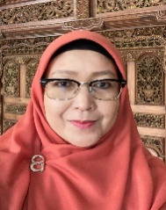Born in Palembang, South Sumatra, August 14, 1969. In 1991, she completed his education in the S1 Program in Mathematics Study Program at the FKIP Sriwijaya University. In 1999, she completed his studies in the S2 Program at IPB in the Statistics Study Program. In 2010, he graduated from the S3 Program at the Jakarta State University, the Educational Research and Evaluation Study Program (PEP).

**Dr. Budi Mulyono, S.Pd., M.Sc.**



Born in Palembang, February 28, 1975. Lecturer at Sriwijaya University. Bachelor's degree in Mathematics Education, Sriwijaya University, Palembang, graduated in (1998); Master's degree in Mathematics Education, Universiteit Van Amsterdam, graduated in (2010). Doctoral degree in Mathematics Education, Indonesian University of Education, graduated in (2020).

**Dr. Ely Susanti, M.Pd.**

Born in Palembang, September 29, 1980. Lecturer at Sriwijaya University. Bachelor's degree in Mathematics Education, Sriwijaya University, Palembang, graduated in (2002); Master's degree in Mathematics Education, Sriwijaya University, Palembang, graduated in (2008), Doctoral in Mathematics Education, Indonesian Education University (UPI), graduated in (2014).